Contact

Send you Cv’s to hr@mazco.com.sa

Or

Post Box: 2486, Dammam 31451,
KINGDOM OF SAUDI ARABIA.
Tell: +966 3 8260080 EXT: 31
Fax : +966 3 8266618
Website::www.mazco.com.sa

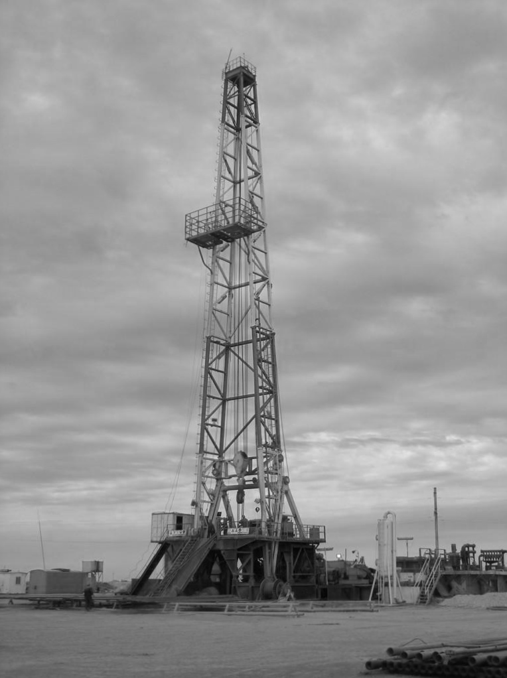

Rig Mechanic

Job Description:

Rig Mechanic shall:

    - Perform the supervisory functions common to the segment level.
    - Maintain a vigilant effort to assess the condition of mechanical components during the course of normal operations in conjunction with a proactive, computer generated preventive maintenance program to minimize equipment downtime or unsafe situations. Prepare and maintain up-to-date maintenance records for all rig equipment and schedule work relating to the preventive maintenance (PM) program in the most efficient and least disruptive manner within a specified time-frame dictated by the preventive maintenance program.
    - Diagnose and supervise repairs on malfunctioning equipment of all types, including diesel and gasoline engines, rig draw works, power end of mud pumps, air compressors, transmissions, rotary tables, rotary and power swivels and related equipment to ensure continuity of operations.
    - Conduct safety and housekeeping checks to ensure proper practices are observed. Advise rig foreman and crew members on the proper care and operation of the equipment in use.
    - Supervise, direct and train skilled and semi-skilled craftsmen performing mechanical maintenance, pipefitting, plumbing, welding and building craft activities on the rig or at camp facilities. Establish work priorities, provide drawings or sketches as required, assure safe practices are observed and inspect completed work.
    - Carry out on and off the job training programs for employees undergoing mechanical and welder training. Closely supervise trainee activities, evaluate their performance, certify task completion on the skills checklist and identify individuals capable of further development.
    - Supervise and monitor hydraulic crane activities and the operators. Assure safe practices are observed and the equipment is properly maintained.
    - Perform periodic checks and routine maintenance on water well engines, booster pumps and waterlines serving as the rig water supply. Report major malfunctions and monitor repairs.
    - Initiate spare parts and third-party repair requests and verify receipt of materials. Assess requirements and prepare list of spare parts to be catalogued as warehouse stock items for all rig equipment.
    - Review and modify existing equipment PM task lists and assist in preparation of new PM task lists for upload into the computerized maintenance program.
    - Assist the maintenance planners and material control men in preparation of work orders including labour and parts cost estimates as part of the overall maintenance program.
    - Review monthly cost sheets and assess means to reduce expenditures and improve cost effectiveness.
    - Actively assist in handling any emergency, which may occur at the rig or at camp facilities.
    - Teach SAUDI ARAMCO Drilling and Work over employees in accordance with PM System.
    - Teach and train maintenance staff.
    - Teach how to document current condition of equipment and/or sub-assemblies prior to commencing repairs.
    - Teach how to inspect equipment troubleshoot mechanical, hydraulic, electromechanical and electronic systems and isolate the subsystems or components that might have caused the problem.
    - Teach how to perform all tests and repair in strict compliance with the equipment manufacturer's service manual and bulletins.

- Teach how to inspect parts for wear and replacement to prevent equipment failures.
- Teach how to list parts to be replaced referring to manufacturer's manuals and diagrams.
- Teach how to perform post-overhaul/repair checks for leaks or malfunctions.
- Teach how to document inspections, test results, repair work done and parts replaced for proper billing and record upkeep.
- Teach how to use personal protective gear and follow shop safety practices as required while working.
- Teach how to maintain cost controls in an effort to reduce costs without compromising maintenance quality.

Qualification:
  - Have a minimum of ten years of experience in operating and maintaining diesel/electric rig components and related equipment, including Top Drive.
  - Have a working knowledge of other crafts and operations such as welding, pipefitting, crane operations, plumbing carpentry etc.
  - Have the capability of reading and understanding mechanical blueprints, equipment spare parts and service manuals.
  - Have ability to supervise, motivate, train and coordinate subordinates.
  - Be fluent in spoken and written English.
  - Colloquial Arabic is desirable but not required.
  - Familiar with oilfield terminology.
  - Have a working knowledge of drilling operation to ensure knowledgeable recommendations/decisions are made to minimize interruption of rig operations.
  - Must be willing to work and live in isolated locations under drilling camp conditions.
  - Have a valid Saudi driving license or a Saudi Arab government acceptable international license to drive vehicles.

